Functional Requirements

1. Student Management
FR1.1 – Student Sign Up
- A student can create an account with studentId, name, email, and password.
FR1.2 – Student Login
- A student can log in using studentId and password.
FR1.3 – Student Profile
- A student can view their own profile, which includes:
  - Basic details (studentId, name, email).
  - A list of courses the student has applied for with status:
    - Enrolled (enrolled == active , even if start date is in future)
    - Waitlisted (position in queue also shown)
    - Completed / Dropped (Past courses, which are no longer active, either dropped or completed)

2. Course Management
FR2.1 – Preloaded Courses
- Courses are preloaded in DynamoDB (no admin interface).
FR2.2 – Course Attributes
Each course must have:
- courseId (unique identifier)
- courseName
- maxSeats
- currentEnrolledCount (auto-updated on enroll/drop)
- startDate
- endDate
- duration (computed when needed, not stored in DB)
- latestEnrollmentBy (last enrollment date)
FR2.3 – View Courses
- Students can view all available courses with seat availability:
  - currentEnrolledCount
  - remainingSeats = maxSeats – currentEnrolledCount
FR2.4 – Enrollment Cutoff
- Students can only enroll if current date ≤ latestEnrollmentBy.
FR2.5 – Drop Cutoff
- Students can only drop if current date ≤ endDate.

3. Enrollment
FR3.1 – Course Enrollment
A student can enroll in a course if:
- Current date ≤ latestEnrollmentBy
- currentEnrolledCount < maxSeats
- Student has fewer than 5 active courses
FR3.2 – Course Drop
- A student can drop a course if:
  - Current date ≤ endDate
- On drop → currentEnrolledCount –= 1
FR3.3 – Enrollment Count Update
- On successful enroll → currentEnrolledCount += 1
- On drop → currentEnrolledCount –= 1
FR3.4 – Prevent Duplicate Enroll
- A student cannot enroll or waitlist twice for the same course.

4. Waitlist Management
FR4.1 – Waitlist Placement
- If a course is full, the student is placed in a FIFO waitlist queue.
- A student can be on waitlists for up to 3 courses.
FR4.2 – Auto Enrollment from Waitlist
When a seat opens:
- Check the first student in the waitlist.
- If that student’s activeEnrollments < 5, auto-enroll them and increment currentEnrolledCount.
- If the student already has 5 active courses → keep them in waitlist and check the next student.
- The skipped student remains at the front of the queue.
FR4.3 – Simultaneous Seat Openings
- If multiple courses have availability at the same time, a student is only auto-enrolled until the max enrollment limit (5) is reached.
- First processed wins → whichever seat opening is processed first gets allocated.
FR4.4 – Waitlist Status View
- Students can view which courses they are waitlisted for and their position in the queue.
- Opt-out Feature: Students can choose to remove themselves from the waitlist for a specific course.
  - Once opted out, the student will no longer be considered for auto-enrollment in that course.
  - The waitlist positions of other students adjust accordingly.

5. Seat Availability
FR5.1 – Real-time Seat Check
- Every enroll attempt must check seat availability before confirming.
FR5.2 – Atomic Updates
- Seat count updates are atomic to prevent overbooking.

6. Audit Logging
FR6.1 – Action Logging
Every key action must be recorded in a StudentLogs table in DynamoDB:
- Sign up
- Login
- Enroll
- Drop
- Waitlist Join
- Auto-enroll from waitlist
FR6.2 – Log Attributes
Each log entry must include:
- logId (unique, e.g., UUID or timestamp)
- studentId
- action
- courseId (if applicable)
- timestamp

⚖️ System Constraints
C1 – Enrollment Limit
- A student can be enrolled in a maximum of 5 courses simultaneously.
C2 – Waitlist Limit
- A student can be waitlisted in a maximum of 3 courses simultaneously.
C3 – Course Drop Limit
- A student cannot drop a course after its endDate.
C4 – Course Enrollment Limit
- A student cannot enroll or join a waitlist after latestEnrollmentBy.
- A student cannot enroll if currentEnrolledCount = maxSeats

Non Functional Requirements

Non-Functional Requirements

1. Usability
- NFR1.1 – The system must display clear and meaningful messages for all operations (e.g., “Course full”, “Enrollment closed”, “Already enrolled”).
- NFR1.2 – Students must be able to view all their enrollments, waitlists, and logs in one place.
- NFR1.3 – The workflow for sign up → login → enroll/drop must be simple and intuitive.

2. Maintainability & Extensibility
- NFR2.1 – The system must follow a modular structure:
  - Student Service (sign up, login, profile)
  - Course Service (view, enroll, drop)
  - Waitlist Service (manage queue, auto-enroll)
  - Log Service (student action logs)
- NFR2.2 – Future features (like fees, advanced waitlist rules) should be addable without large changes to existing code.
- NFR2.3 – Business logic must be separated from data access (clean layering).

3. Audit & Logging
- NFR3.1 – Every key student action (sign up, login, enroll, drop, waitlist join, auto-enroll) must be logged.
- NFR3.2 – Logs must include studentId, action, courseId (if applicable), and timestamp.
- NFR3.3 – Logs must be append-only (no updates/deletes).

4. Basic Security
NFR4.1 – Password Storage
Passwords must be hashed and salted (e.g., SHA-256 + salt, or bcrypt if available) before storing in DynamoDB.
NFR4.2 – Session Handling
On successful login, a session token (random UUID) must be generated and stored (in DynamoDB or memory).
- All subsequent requests must use this session token.
- Session must expire after a fixed time (e.g., 30 minutes of inactivity).
NFR4.3 – Access Control
A student must only be able to:
- View/update their own profile.
- View their own enrollments, waitlists, and logs.
- Be restricted from accessing other students’ data.
NFR4.4 – Input Validation
The system must validate inputs to prevent invalid data (e.g., empty studentId, invalid courseId, duplicate email).
NFR4.5 – Log Protection
Audit logs must be append-only (no update/delete). Once an action is logged, it cannot be altered.
NFR4.6 – Minimal Data Exposure
When viewing profiles, sensitive data like hashed passwords must never be displayed or returned in any API response.

5. Basic Reliability
- NFR5.1 – Seat allocation must be atomic (no double booking).
- NFR5.2 – If a course is full, the system must always redirect the student to the waitlist option instead of failing silently.
- NFR5.3 – If a dropped seat is processed, the next eligible waitlist student must always be considered.

UseCase Diagram
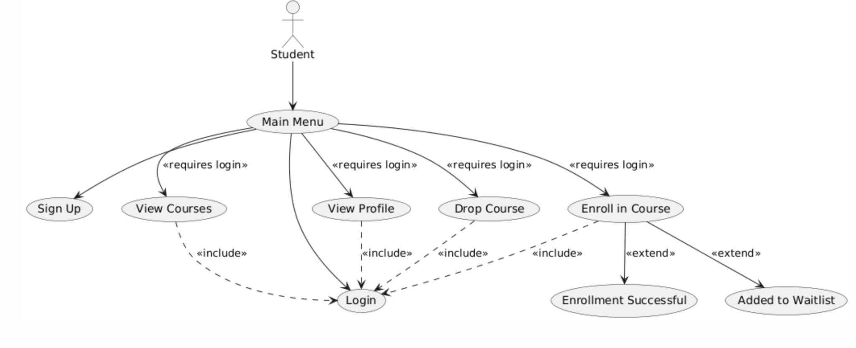

@startuml
actor Student

' Main entry point
usecase "Main Menu" as UC0
usecase "Sign Up" as UC1
usecase "Login" as UC2

' Student internal features
usecase "View Profile" as UC3

' Course-related features
usecase "View Courses" as UC5
usecase "Enroll in Course" as UC6
usecase "Enrollment Successful" as UC6a
usecase "Added to Waitlist" as UC6b
usecase "Drop Course" as UC7

' Relationships

' Main menu flow
Student --> UC0
UC0 --> UC1
UC0 --> UC2

' Features accessible only after login via Main Menu
UC0 --> UC3 : <<requires login>>
UC0 --> UC5 : <<requires login>>
UC0 --> UC6 : <<requires login>>
UC0 --> UC7 : <<requires login>>

' Login is included when accessing any feature
UC3 ..> UC2 : <<include>>
UC5 ..> UC2 : <<include>>
UC6 ..> UC2 : <<include>>
UC7 ..> UC2 : <<include>>

' Enrollment outcomes
UC6 --> UC6a : <<extend>>
UC6 --> UC6b : <<extend>>

@enduml

Class Diagram
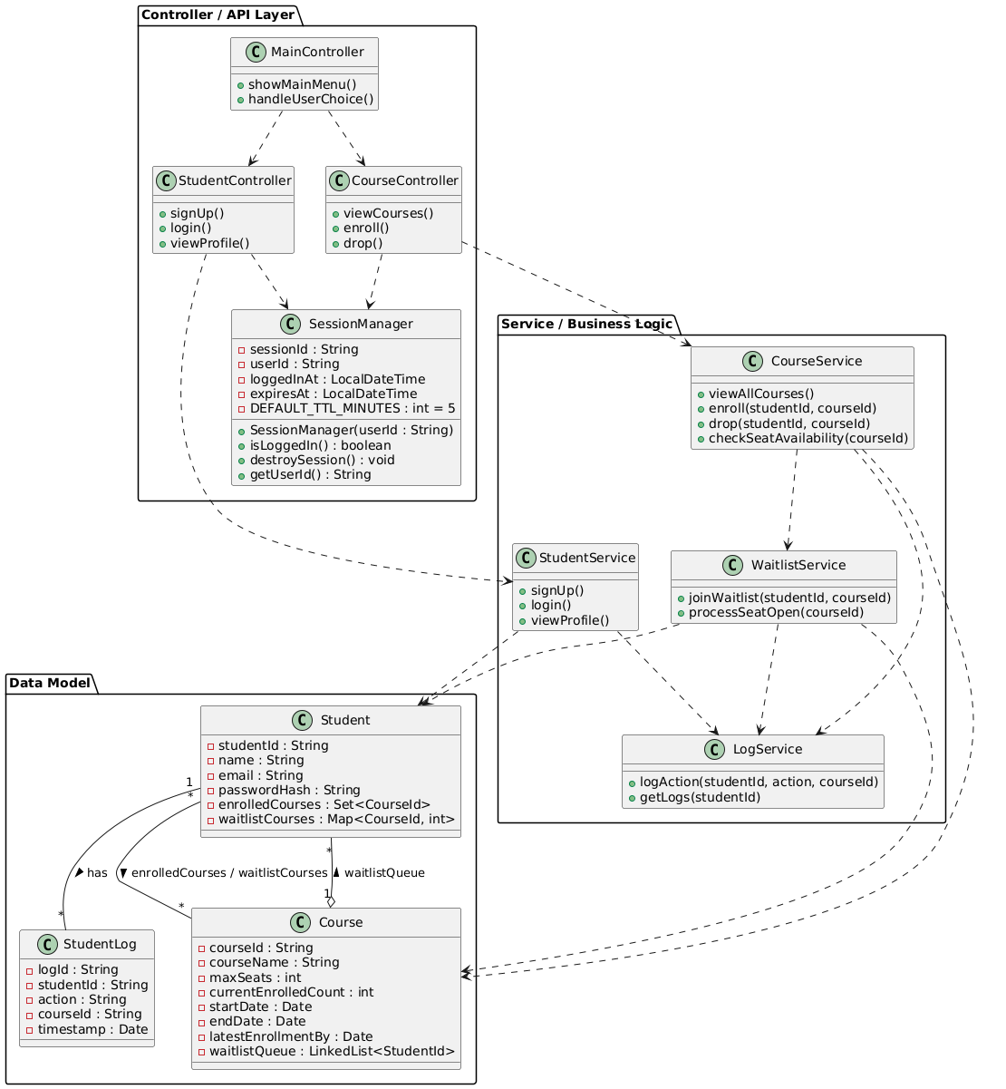
@startuml
package "Data Model" {
class Student {
- studentId : String
- name : String
- email : String
- passwordHash : String
- enrolledCourses : Set<CourseId>
- waitlistCourses : Map<CourseId, int>
}

class Course {
- courseId : String
- courseName : String
- maxSeats : int
- currentEnrolledCount : int
- startDate : Date
- endDate : Date
- latestEnrollmentBy : Date
- waitlistQueue : LinkedList<StudentId>
}

class StudentLog {
- logId : String
- studentId : String
- action : String
- courseId : String
- timestamp : Date
}
}

package "Service / Business Logic" {
class StudentService {
+ signUp()
+ login()
+ viewProfile()
}

class CourseService {
+ viewAllCourses()
+ enroll(studentId, courseId)
+ drop(studentId, courseId)
+ checkSeatAvailability(courseId)
}

class WaitlistService {
+ joinWaitlist(studentId, courseId)
+ processSeatOpen(courseId)
}

class LogService {
+ logAction(studentId, action, courseId)
+ getLogs(studentId)
}
}

package "Controller / API Layer" {
class MainController {
+ showMainMenu()
+ handleUserChoice()
}

class StudentController {
+ signUp()
+ login()
+ viewProfile()
}

class CourseController {
+ viewCourses()
+ enroll()
+ drop()
}
class SessionManager {
- sessionId : String
- userId : String
- loggedInAt : LocalDateTime
- expiresAt : LocalDateTime
- DEFAULT_TTL_MINUTES : int = 5

+ SessionManager(userId : String)
+ isLoggedIn() : boolean
+ destroySession() : void
+ getUserId() : String
}
}

' Relationships

' Domain relationships
Student "1" -- "*" StudentLog : has >
Student "*" -- "*" Course : enrolledCourses / waitlistCourses >
Course "1" o-- "*" Student : waitlistQueue >

' Services use Domain
StudentService ..> Student
StudentService ..> LogService
CourseService ..> Course
CourseService ..> WaitlistService
CourseService ..> LogService
WaitlistService ..> Student
WaitlistService ..> Course
WaitlistService ..> LogService

' Controllers call Services
MainController ..> StudentController
MainController ..> CourseController
StudentController ..> StudentService
CourseController ..> CourseService
CourseController ..> SessionManager
StudentController ..> SessionManager
@enduml

Updated Class Diagram
Added Enrollment entity to help manage course enrollments and waitlists also ensuring persistence.
Hence no need of redundant methods to store course, waitlists in student service, course
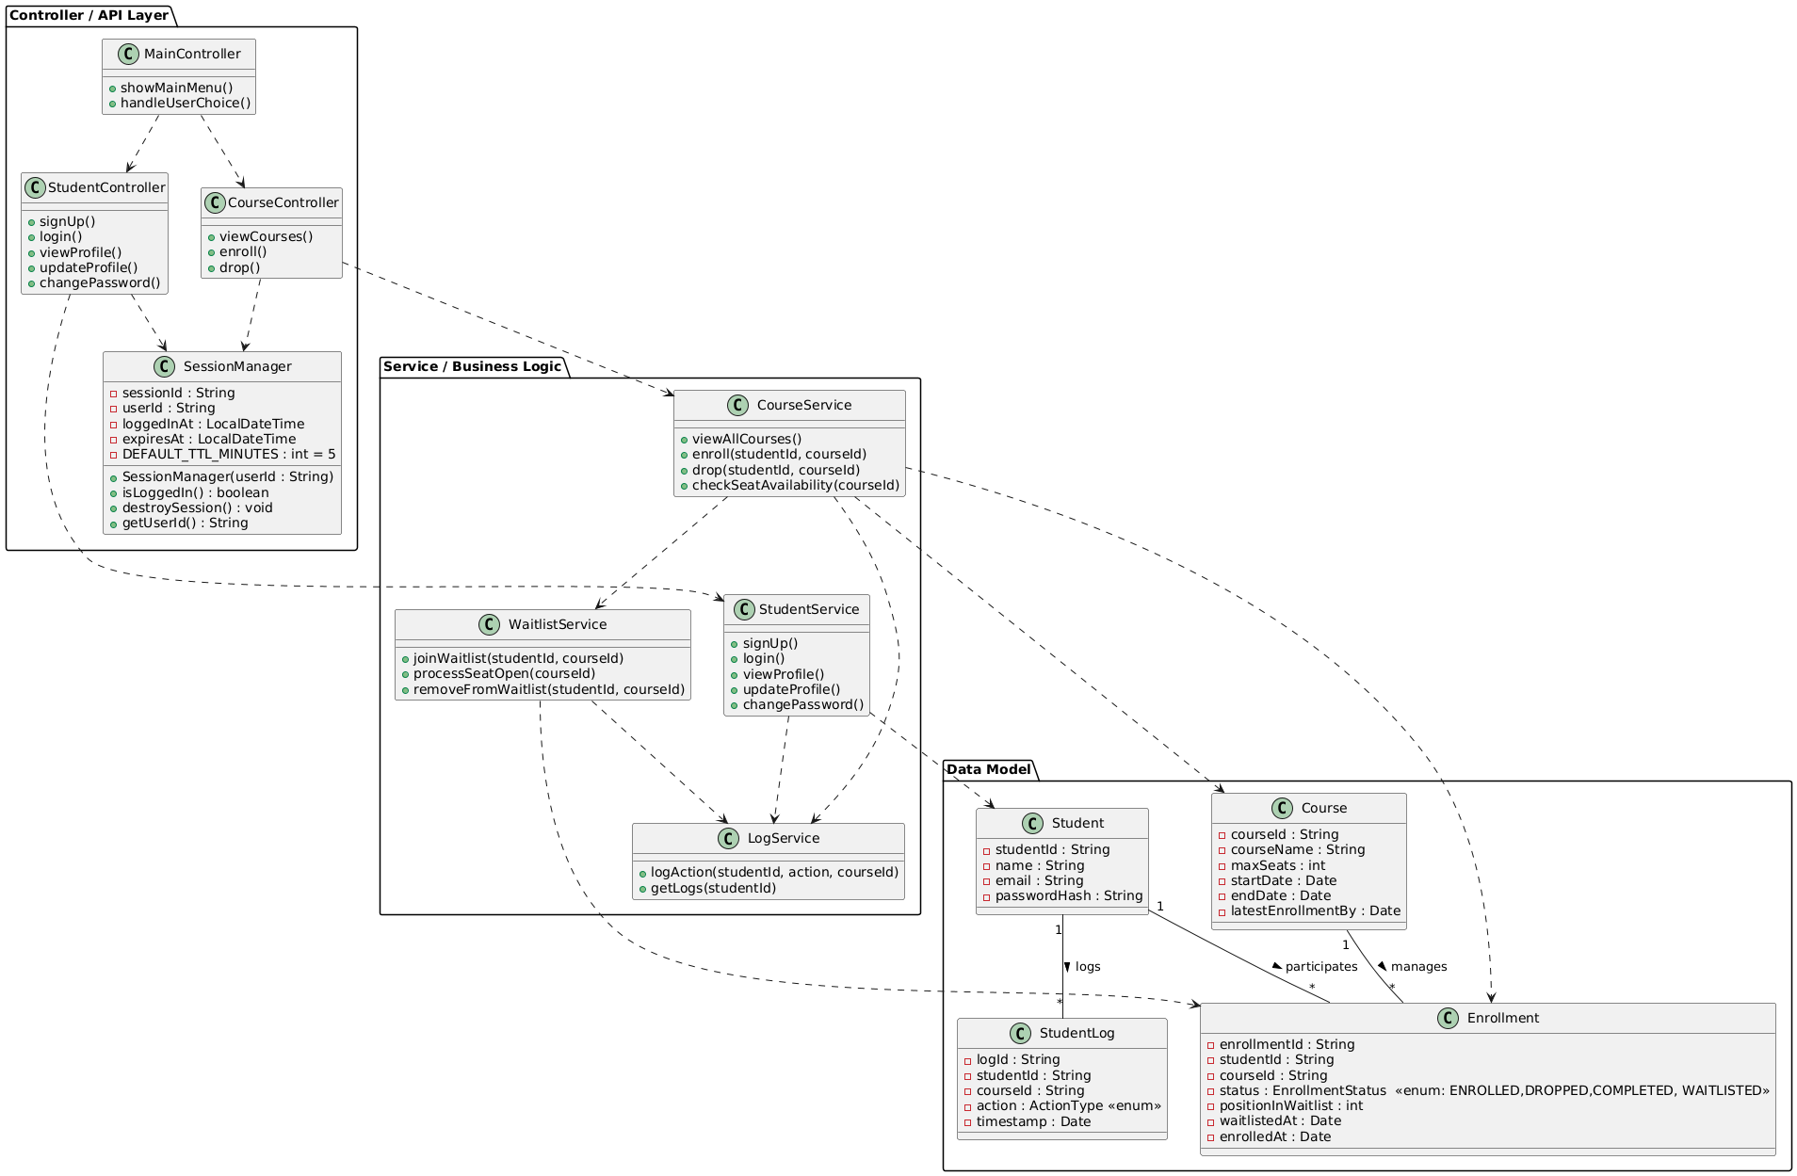
@startuml
package "Data Model" {
class Student {
- studentId : String
- name : String
- email : String
- passwordHash : String
}

class Course {
- courseId : String
- courseName : String
- maxSeats : int
- startDate : Date
- endDate : Date
- latestEnrollmentBy : Date
}

class Enrollment {
- enrollmentId : String
- studentId : String
- courseId : String
- status : EnrollmentStatus <<enum: ENROLLED,DROPPED,COMPLETED, WAITLISTED>>
- positionInWaitlist : int
- waitlistedAt : Date
- enrolledAt : Date
}

class StudentLog {
- logId : String
- studentId : String
- courseId : String
- action : ActionType <<enum>>
- timestamp : Date
}
}

package "Service / Business Logic" {
class StudentService {
+ signUp()
+ login()
+ viewProfile()
+ updateProfile()
+ changePassword()
}

class CourseService {
+ viewAllCourses()
+ enroll(studentId, courseId)
+ drop(studentId, courseId)
+ checkSeatAvailability(courseId)
}

class WaitlistService {
+ joinWaitlist(studentId, courseId)
+ processSeatOpen(courseId)
+ removeFromWaitlist(studentId, courseId)
}

class LogService {
+ logAction(studentId, action, courseId)
+ getLogs(studentId)
}

}

package "Controller / API Layer" {
class MainController {
+ showMainMenu()
+ handleUserChoice()
}

class StudentController {
+ signUp()
+ login()
+ viewProfile()
+ updateProfile()
+ changePassword()
}

class CourseController {
+ viewCourses()
+ enroll()
+ drop()
}

class SessionManager {
- sessionId : String
- userId : String
- loggedInAt : LocalDateTime
- expiresAt : LocalDateTime
- DEFAULT_TTL_MINUTES : int = 5

+ SessionManager(userId : String)
+ isLoggedIn() : boolean
+ destroySession() : void
+ getUserId() : String
}
}

' Relationships

' Domain relationships
Student "1" -- "*" Enrollment : participates >
Course "1" -- "*" Enrollment : manages >
Student "1" -- "*" StudentLog : logs >

' Services use Domain
StudentService ..> Student
StudentService ..> LogService
CourseService ..> Course
CourseService ..> Enrollment
CourseService ..> WaitlistService
CourseService ..> LogService
WaitlistService ..> Enrollment
WaitlistService ..> LogService

' Controllers call Services
MainController ..> StudentController
MainController ..> CourseController
StudentController ..> StudentService
StudentController ..> SessionManager
CourseController ..> CourseService
CourseController ..> SessionManager
@enduml

